**DAILY ONLINE ACTIVITIES SUMMARY**

|  |  |  |  |  |  |
| --- | --- | --- | --- | --- | --- |
| **Date:** | **13-06-2020** | | **Name:** | **Shah Dhruvil Amit** | |
| **Sem & Sec** | **6th - B** | | **USN:** | **4AL17CS083** | |
| **Online Test Summary** | | | | | |
| **Subject** | **PAP** | | | | |
| **Max Score** | **30** | **Score** | | **29** | |
| **Certification Course Summary** | | | | | |
| **Course** | **Java programming** | | | | |
| **Certificate Provider** | **E-box** | **Duration** | | | **2 hours** |
| **Coding Challenges** | | | | | |
|  | | | | | |
| **Status: executed** | | | | | |
| **Uploaded the report in GitHub** | | **Yes** | | | |
| **If yes Repository name** | | <https://github.com/DhruvilShah99/Daily-Updates> | | | |
| **Uploaded the report in slack** | | **Yes** | | | |

PAP -IA -4

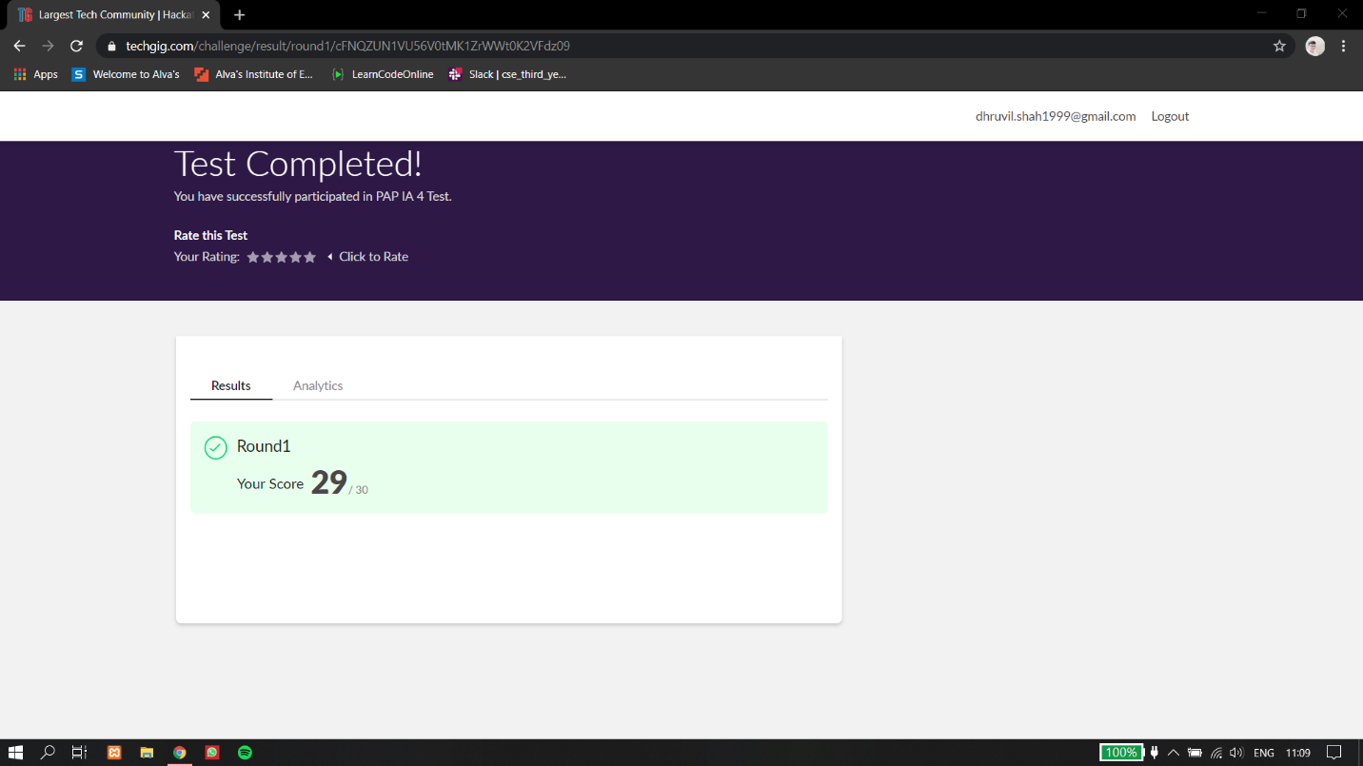

Certification Course Details:

Report-

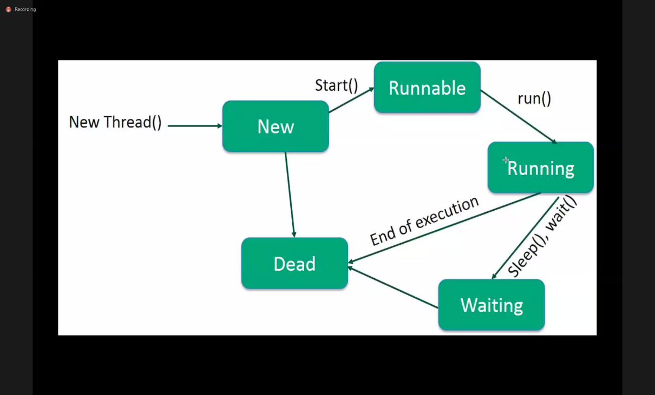

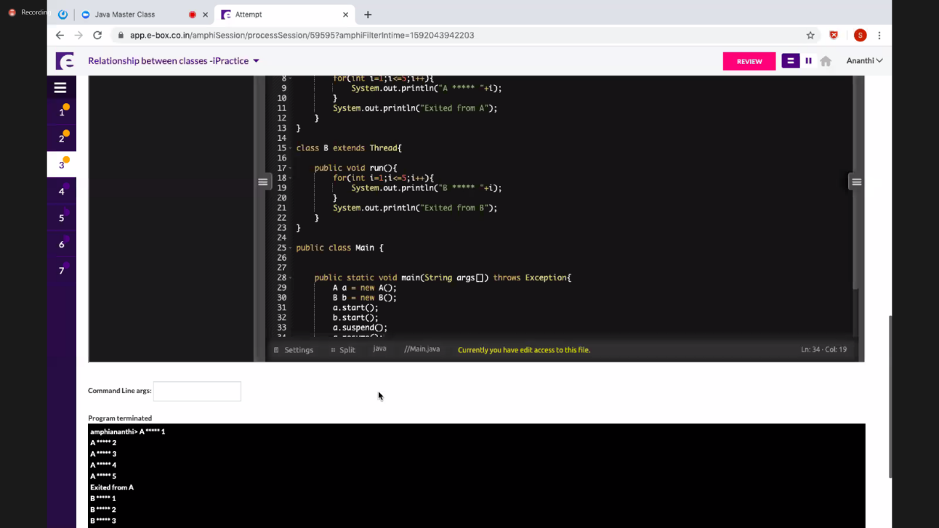

In today’s session of online class, I have learnt about multithreading which defined as the ability of a processor to execute multiple threads concurrently. And multitasking where the operating system decides when to switch tasks external to Python. Learnt some of the methods like resume(), suspend().

Coding Challenges Details:

The below GitHub link for details

<https://github.com/DhruvilShah99/Daily-Updates>

P-1-Write a C Program to calculate Electricity Bill

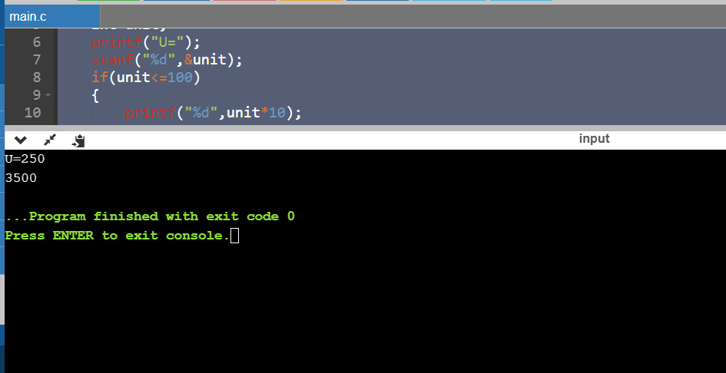

**P-2-**Write a Java Program to determine whether a given matrix is a sparse matrix

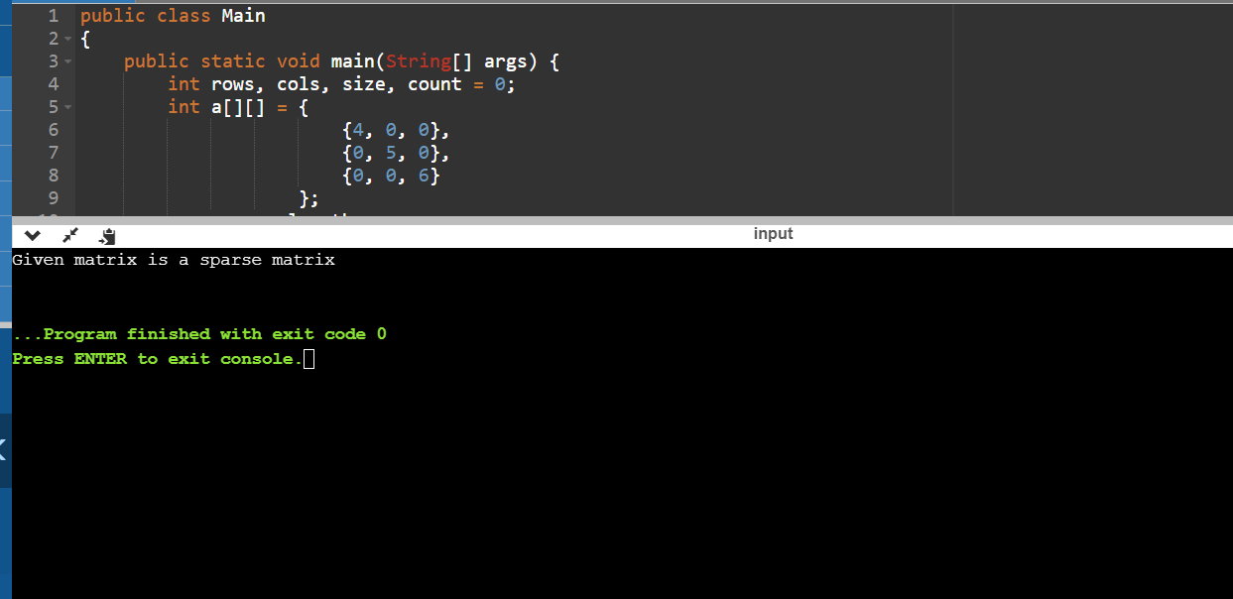

**P-3-**Java program to find the first non repeated character of a given String

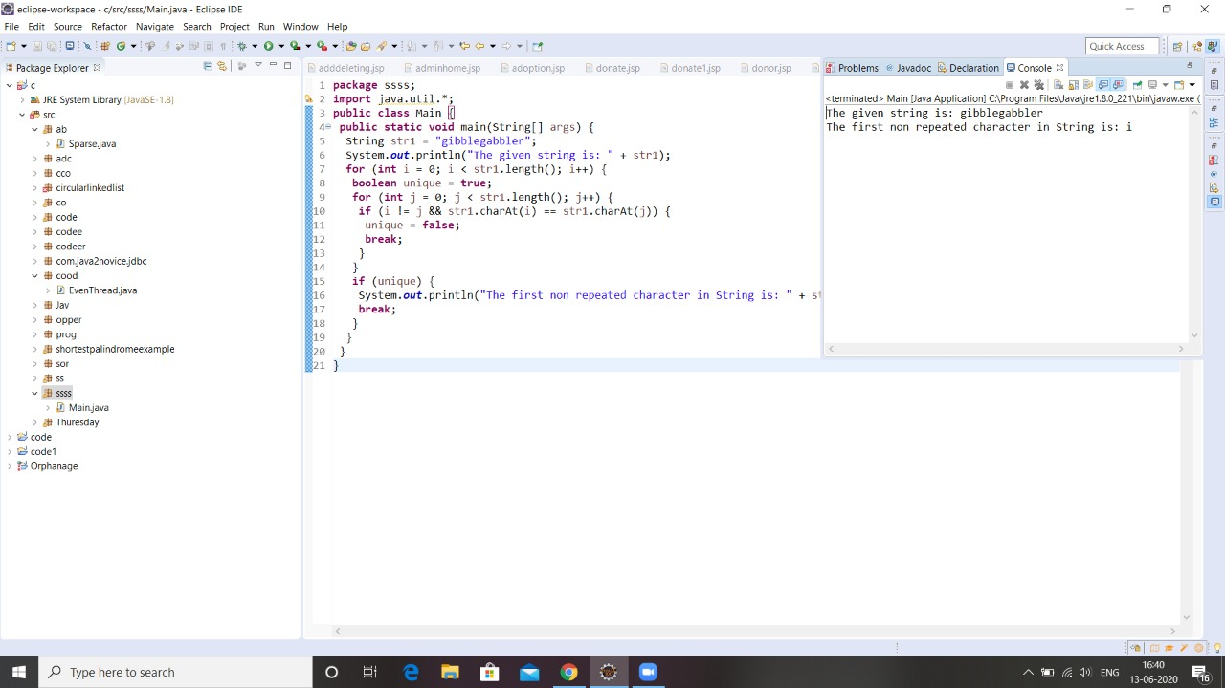

**P-4-**Python Program to print the pattern of alphabets

